PROJECT DESIGN PHASE-II

TECHNOLOGY STACK (ARCHITECTURE & STACK)
Date: 21 September 2026
Team ID: SWTID-2026-6999
Project Name: AI BlogNest API
Maximum Marks: 4 Marks
Technical Architecture
AI BlogNest API is a backend-only REST API architecture. Client requests are sent through Postman to the Node.js and Express.js application. The request passes through authentication, authorization, validation, sanitization, and rate-limiting middleware before reaching the appropriate controller and service layer. The application uses MongoDB Atlas as its cloud database and Google Gemini as the external AI service. MongoDB Atlas Search is used for keyword-based search, while MongoDB Atlas Vector Search is used for semantic search using embeddings.
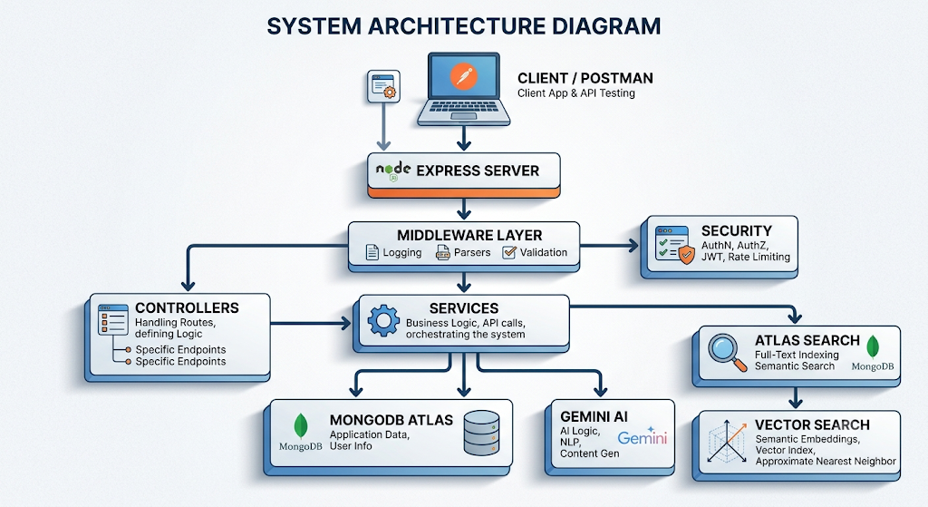
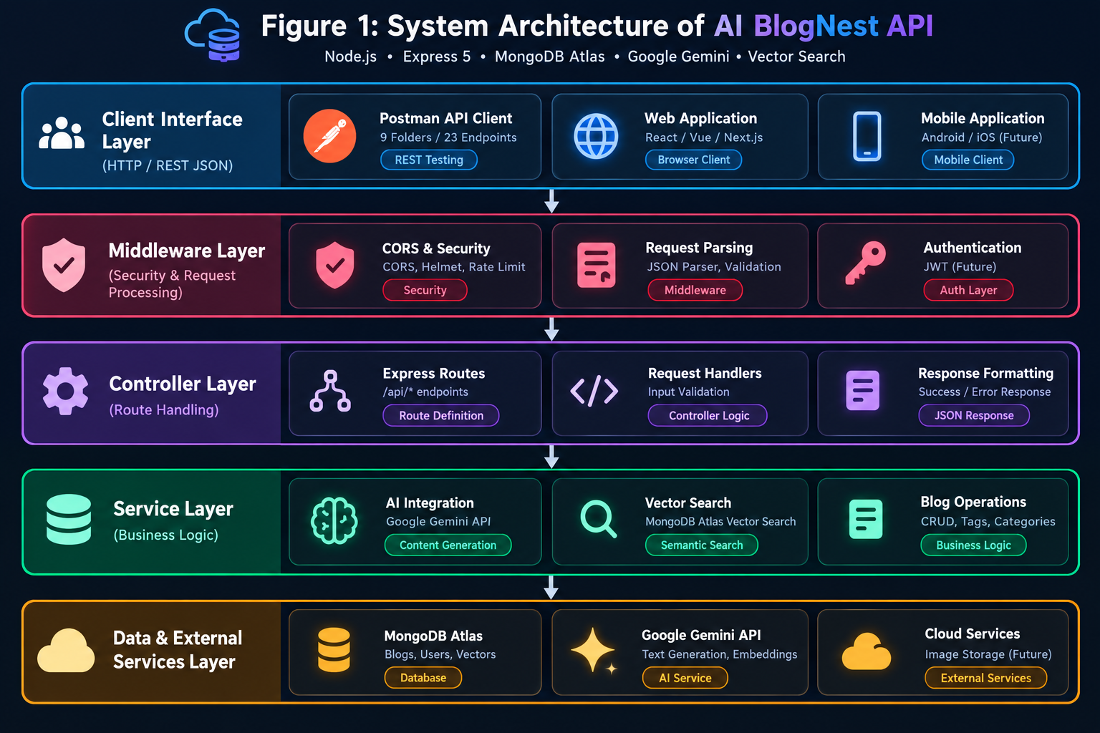
Table 1: Components & Technologies

S.No | Component | Description | Technology
1 | User Interface | API interface through which users/developers interact with the backend | Postman REST API Client
2 | Application Logic-1 | Handles REST API routing, request processing and application flow | Node.js, Express.js
3 | Application Logic-2 | Handles authentication and authorization | JWT, bcryptjs, Express Middleware
4 | Application Logic-3 | Handles AI processing, search and semantic search operations | Google Gemini API, Atlas Search, Atlas Vector Search
5 | Database | Stores users, blogs, categories, comments and application data | MongoDB, Mongoose
6 | Cloud Database | Cloud-hosted database for application data | MongoDB Atlas
7 | File Storage | Stores media path/metadata associated with blog content | Database-stored media metadata
8 | External API-1 | Generates AI-assisted blog content and summaries | Google Gemini API
9 | External API-2 | Not used | Not Applicable
10 | Machine Learning Model | Generates text embeddings for semantic search | Gemini Embedding Model
11 | Infrastructure (Server / Cloud) | Backend runs locally while database and AI services are cloud-based | Local Node.js Server + MongoDB Atlas + Google Gemini Cloud

The BlogNest project specifically uses Node.js, Express.js, MongoDB/Mongoose, Postman, and Google Gemini, while the common template asks the technology architecture to identify storage, external APIs, and machine-learning interfaces.

Table 2: Application Characteristics

S.No | Characteristics | Description | Technology
1 | Open-Source Frameworks | Backend development uses open-source runtime, framework and database technologies | Node.js, Express.js, Mongoose
2 | Security Implementations | Protects user accounts and APIs using authentication, authorization, password hashing, validation, sanitization and rate limiting | JWT, bcryptjs, RBAC, Input Validation, Sanitization, Rate Limiting
3 | Scalable Architecture | Modular MVC and service-based architecture separates routing, controllers, business logic and database operations, allowing additional features to be added independently | MVC, Express.js, Service Layer, MongoDB Atlas
4 | Availability | Cloud-based database and external AI services can be accessed whenever the backend and required cloud services are available | MongoDB Atlas, Google Gemini API
5 | Performance | Uses database indexing, pagination, filtered queries and dedicated search/vector-search mechanisms to process content efficiently | Mongoose, MongoDB Indexes, Atlas Search, Atlas Vector Search

Technology Stack Summary

Backend
Node.js + Express.js

Database
MongoDB Atlas + Mongoose

Authentication
JWT + bcryptjs

AI
Google Gemini API

Keyword Search
MongoDB Atlas Search

Semantic Search
MongoDB Atlas Vector Search

Embeddings
Gemini Embedding Model

API Testing
Postman

Development Environment
Visual Studio Code

